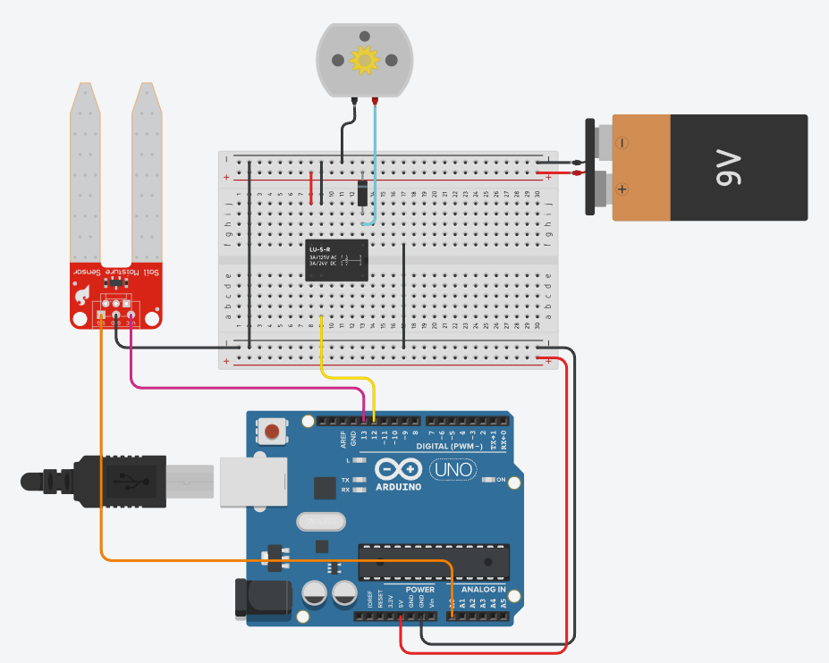
unsigned long previousMilis = 0;
const unsigned long interval = 2000;
const int threshold = 400;

void setup() {
Serial.begin(9600);
pinMode(13, OUTPUT);
pinMode(12, OUTPUT);
}

void loop() {
if(millis() - previousMilis >= interval) {
previousMilis = millis();
digitalWrite(13, HIGH);
int moistureSensor = analogRead(A0);
Serial.print(""+String(moistureSensor)+"\n");
if (moistureSensor >= threshold) {
motorState(LOW);
} else {
motorState(HIGH);
}
delay(10);
digitalWrite(13, LOW);
}
}

void motorState(bool state) {
digitalWrite(12, state? HIGH:LOW);
}

